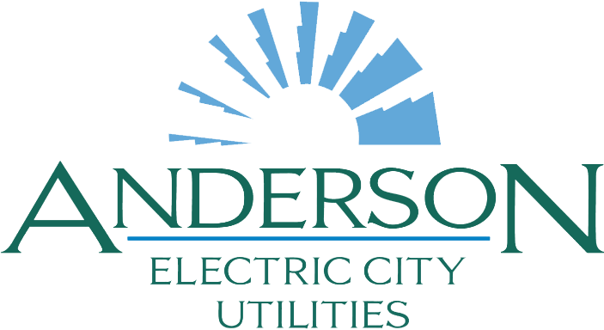

Request for Qualifications (RFQ)
Disaster and Hazard Mitigation Engineering Services
City of Anderson Utilities Division
2/3/2025

I. Purpose
The City of Anderson Utilities Division is seeking qualified engineering firms with expertise in disaster and hazard mitigation to provide consulting and engineering services. The selected firm or firms will assist in developing proactive strategies, plans, and infrastructure improvements to mitigate risks associated with natural disasters.
II. Background
The City of Anderson Utilities Division oversees critical water and wastewater infrastructure essential to public health, safety, and the environment. Given the increasing frequency and intensity of extreme weather events, along with regulatory mandates, it is imperative to develop comprehensive hazard mitigation plans and engineering solutions to protect vital infrastructure and enhance community resilience.
III. Scope of Services
The selected firm will provide professional engineering services, including but not limited to:
- Hazard Mitigation Planning:
  - Risk and vulnerability assessments for utilities infrastructure.
  - Development of Hazard Mitigation Plans (HMPs) in compliance with FEMA requirements.
  - Integration of climate resilience strategies into infrastructure planning.

- Disaster Risk Reduction:
  - Design and engineering solutions to protect utility infrastructure against floods, hurricanes, earthquakes, and other natural disasters.
  - Erosion control and stream bank stabilization to safeguard exposed assets.
  - Evaluation and retrofitting of critical facilities to meet current hazard mitigation standards.
- Permitting and Compliance:
  - Coordination with local, state, and federal agencies to obtain necessary permits.
  - Compliance with FEMA, EPA, and state regulations related to hazard mitigation projects.
- Funding Assistance:
  - Identification of grant opportunities and assistance with applications, including FEMA Hazard Mitigation Assistance (HMA) grants.
  - Preparation of cost-benefit analyses and documentation required for funding applications.
IV. Submission Requirements
Interested firms should submit the following information:
- Firm Overview: Brief history, areas of expertise, and organizational structure.
- Qualifications and Experience: Demonstrated experience with disaster and hazard mitigation projects, including examples of similar work.
- Key Personnel: Resumes and qualifications of personnel who will be assigned to the project.
- Approach and Methodology: Description of the approach to meeting the scope of services.
- References: At least three references from similar projects, including contact information.
- Licenses and Certifications: Proof of licensure to practice engineering in the State of South Carolina and relevant certifications.
- Insurance: Evidence of professional liability insurance and other required coverage.
V. Evaluation Criteria
Submissions will be evaluated based on the following criteria:
- Relevant experience and past performance on similar projects (30%).
- Qualifications of the firm and key personnel (25%).
- Approach to meeting the scope of services (25%).
- Knowledge of applicable regulations and standards (10%).
- Responsiveness and completeness of the submission (10%).
VI. Submission Instructions
Submissions must be received by February 17, 2025, 4:00 PM. Electronic submissions in PDF format should be sent to Alex Kostik, akostik@cityofandersonsc.com, or hard copies can be mailed or delivered to:

City of Anderson Utilities Division
314 Tribble St
Anderson, SC 29625
VII. Additional Information
The City of Anderson reserves the right to reject any or all submissions, waive informalities, and select the firm deemed most advantageous to the City. This RFQ does not obligate the City to award a contract or pay any costs incurred by respondents in the preparation and submission of their qualifications.
VIII. Anticipated Schedule
- RFQ Issuance: February 3, 2025
- Questions Due: January 10, 2025
- Responses to Questions Posted: February 12, 2025
- Submission Deadline: February 17, 2025, 4:00PM
- Selection Announcement: February 19, 2025
We look forward to receiving your qualifications and partnering to enhance the resilience of our community’s vital utility infrastructure.

